TASK 3: HOW TO DO PUPPET AGENT INSTALLATION ON A SLAVE

1 Clone the repository git clone https://github.com/AnjuMeleth/ DevOpsMasterPuppet.git 2 Run the Puppet agent installation script sh puppetagentinstall.sh 3 Open port 8140 sudo ufw allow 8140 4 Edit hosts file to enter the ipaddress of the master and agent with a DNS name puppet and puppet-agent sudo vi /etc/hosts 5 Start the puppet agent sudo systemctl start puppet sudo systemctl enable puppet

Open a new terminal for slave server

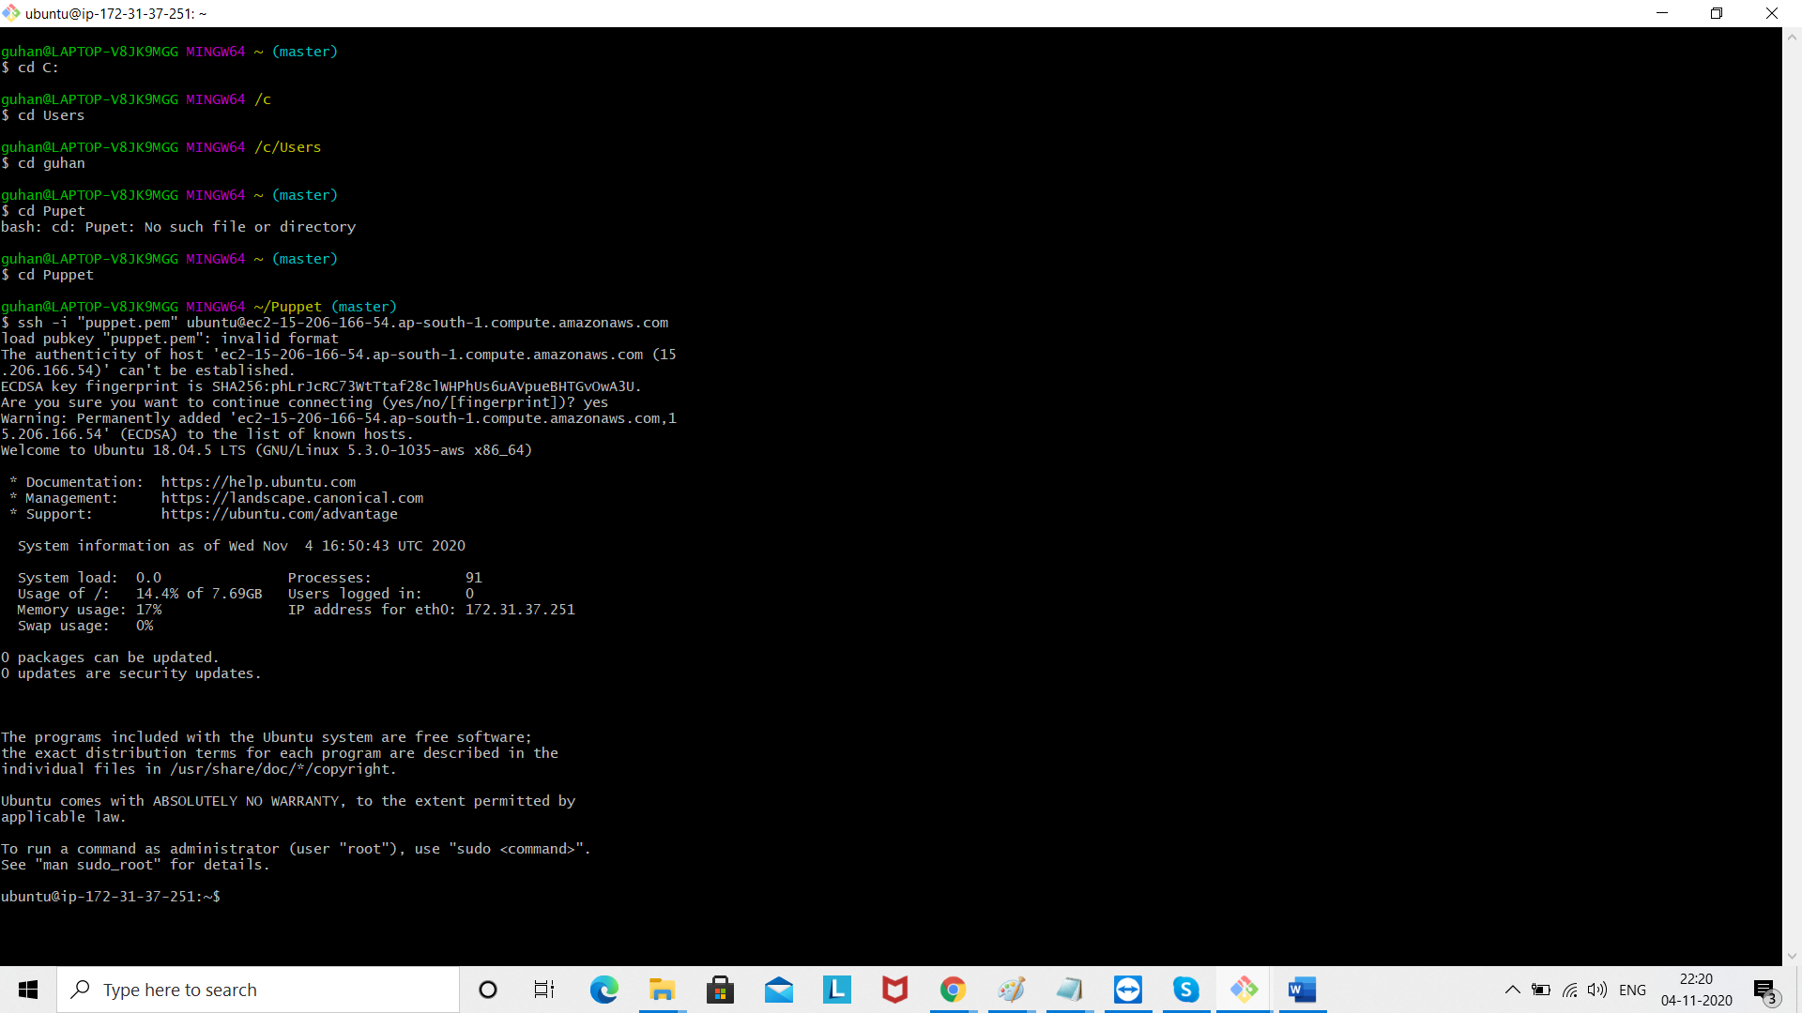

Now git clone repository

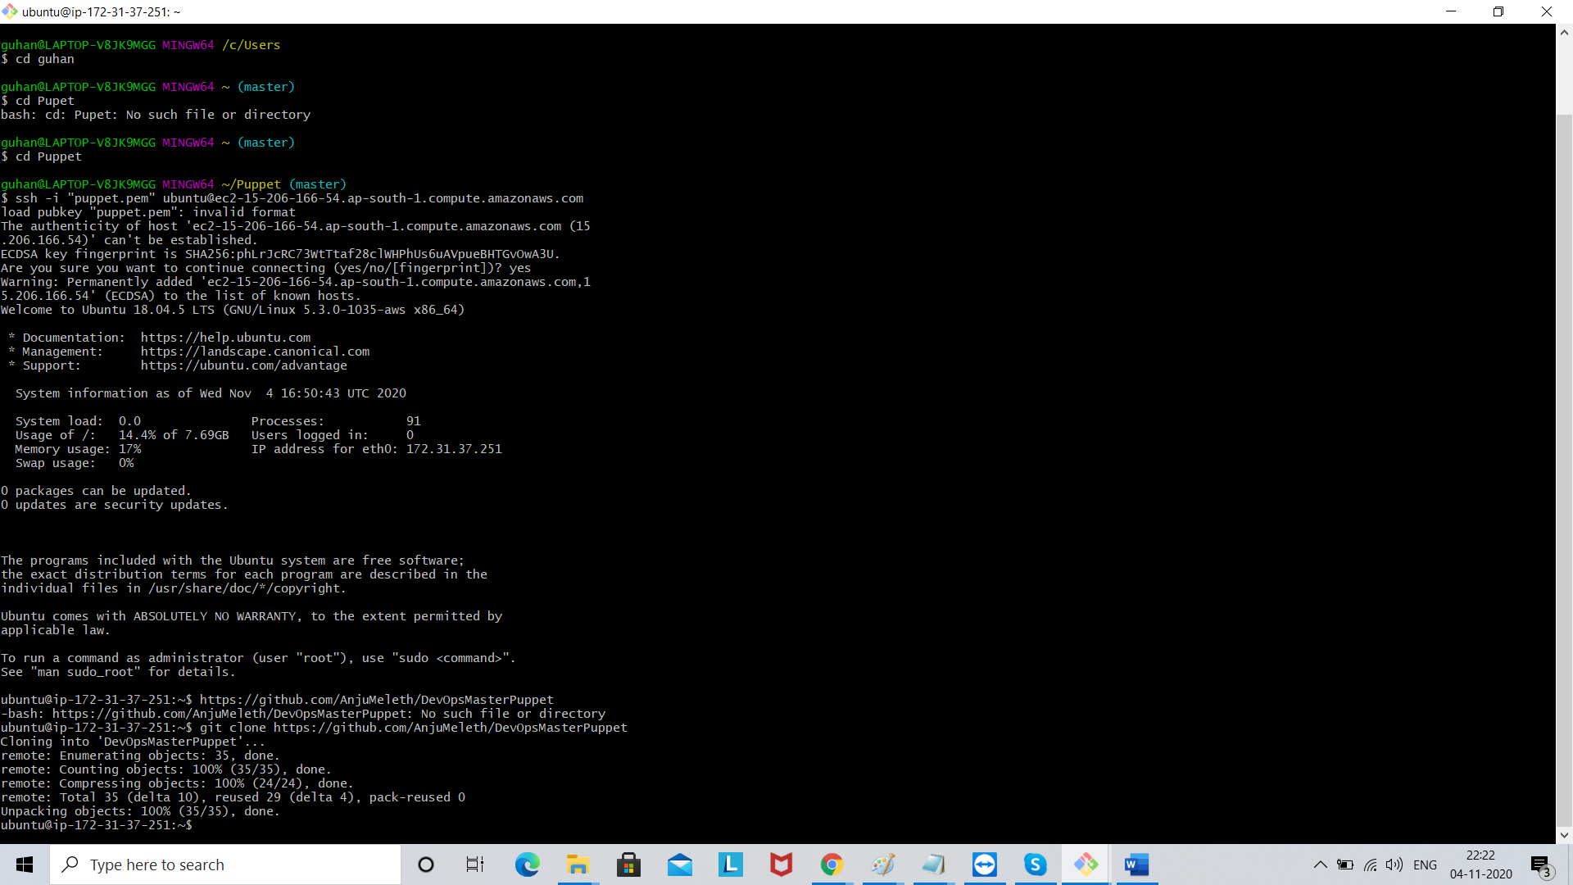

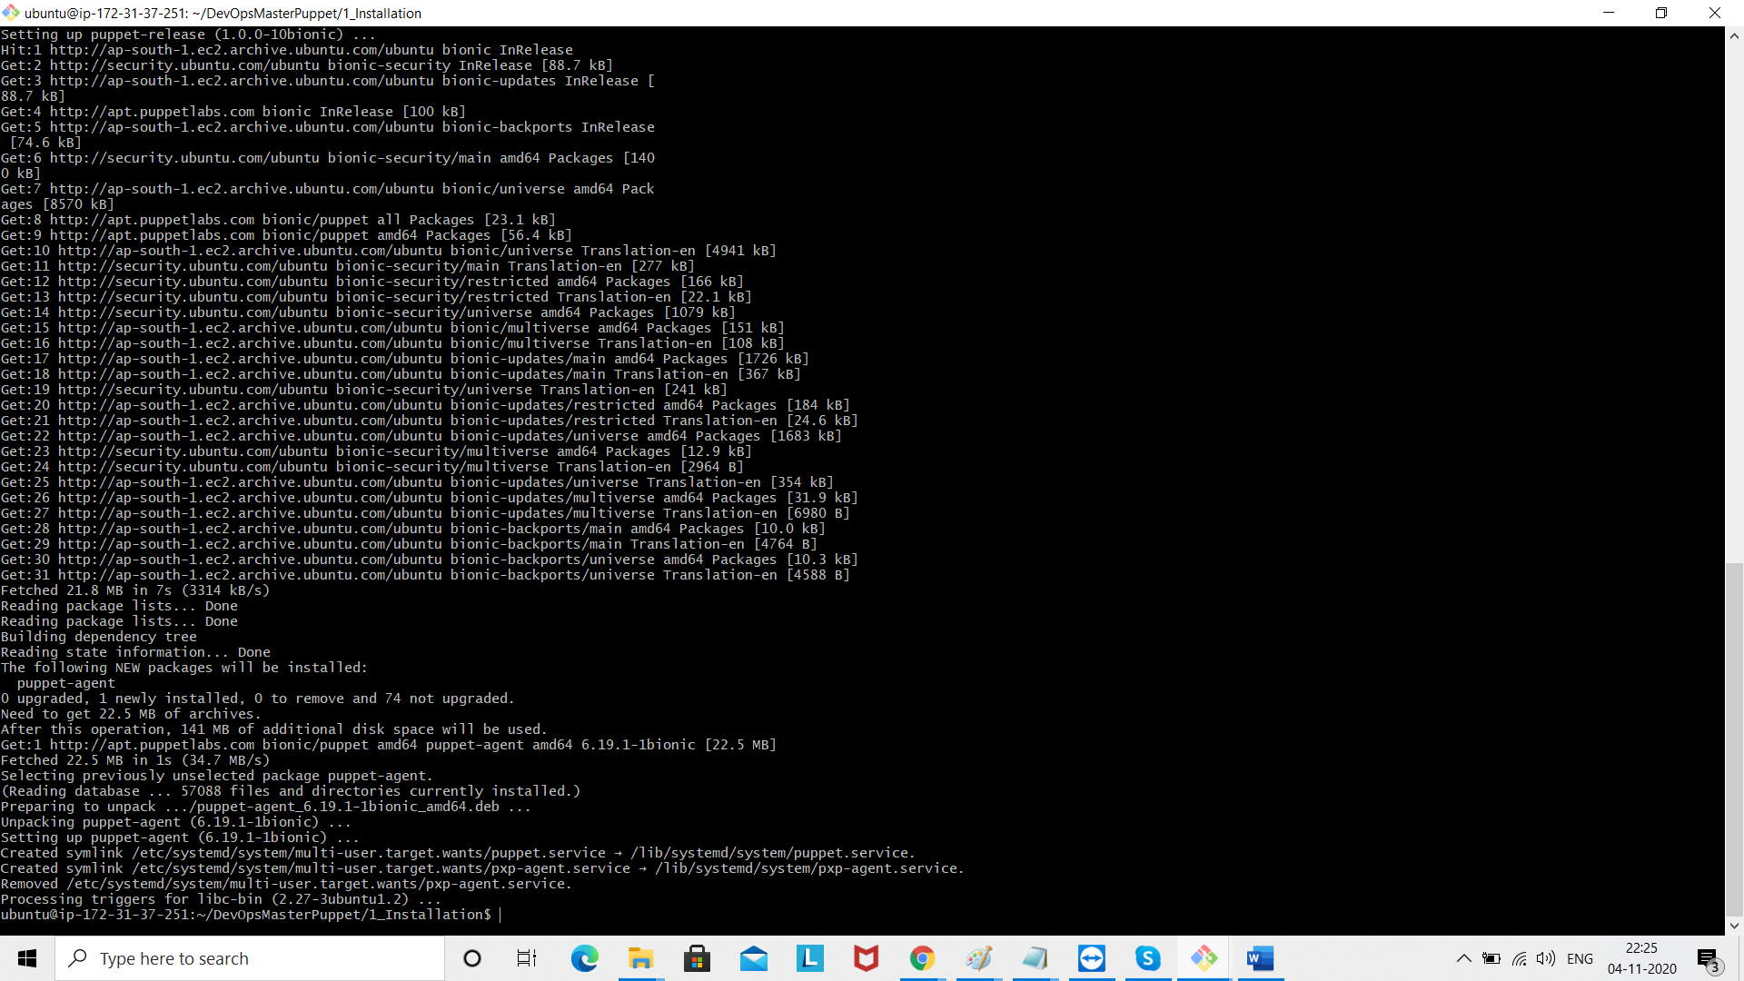

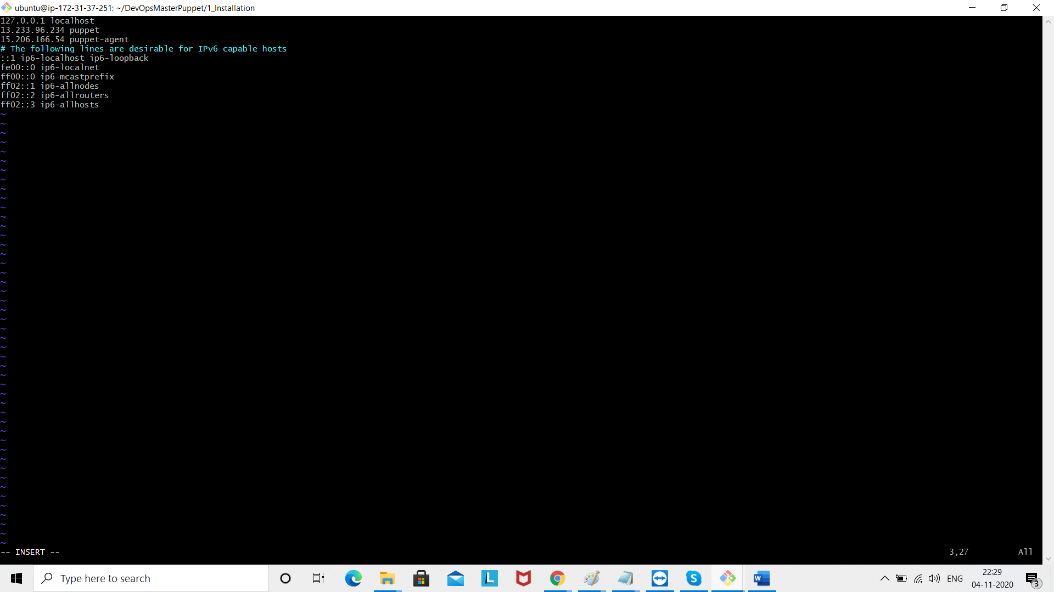

Save the file wq!

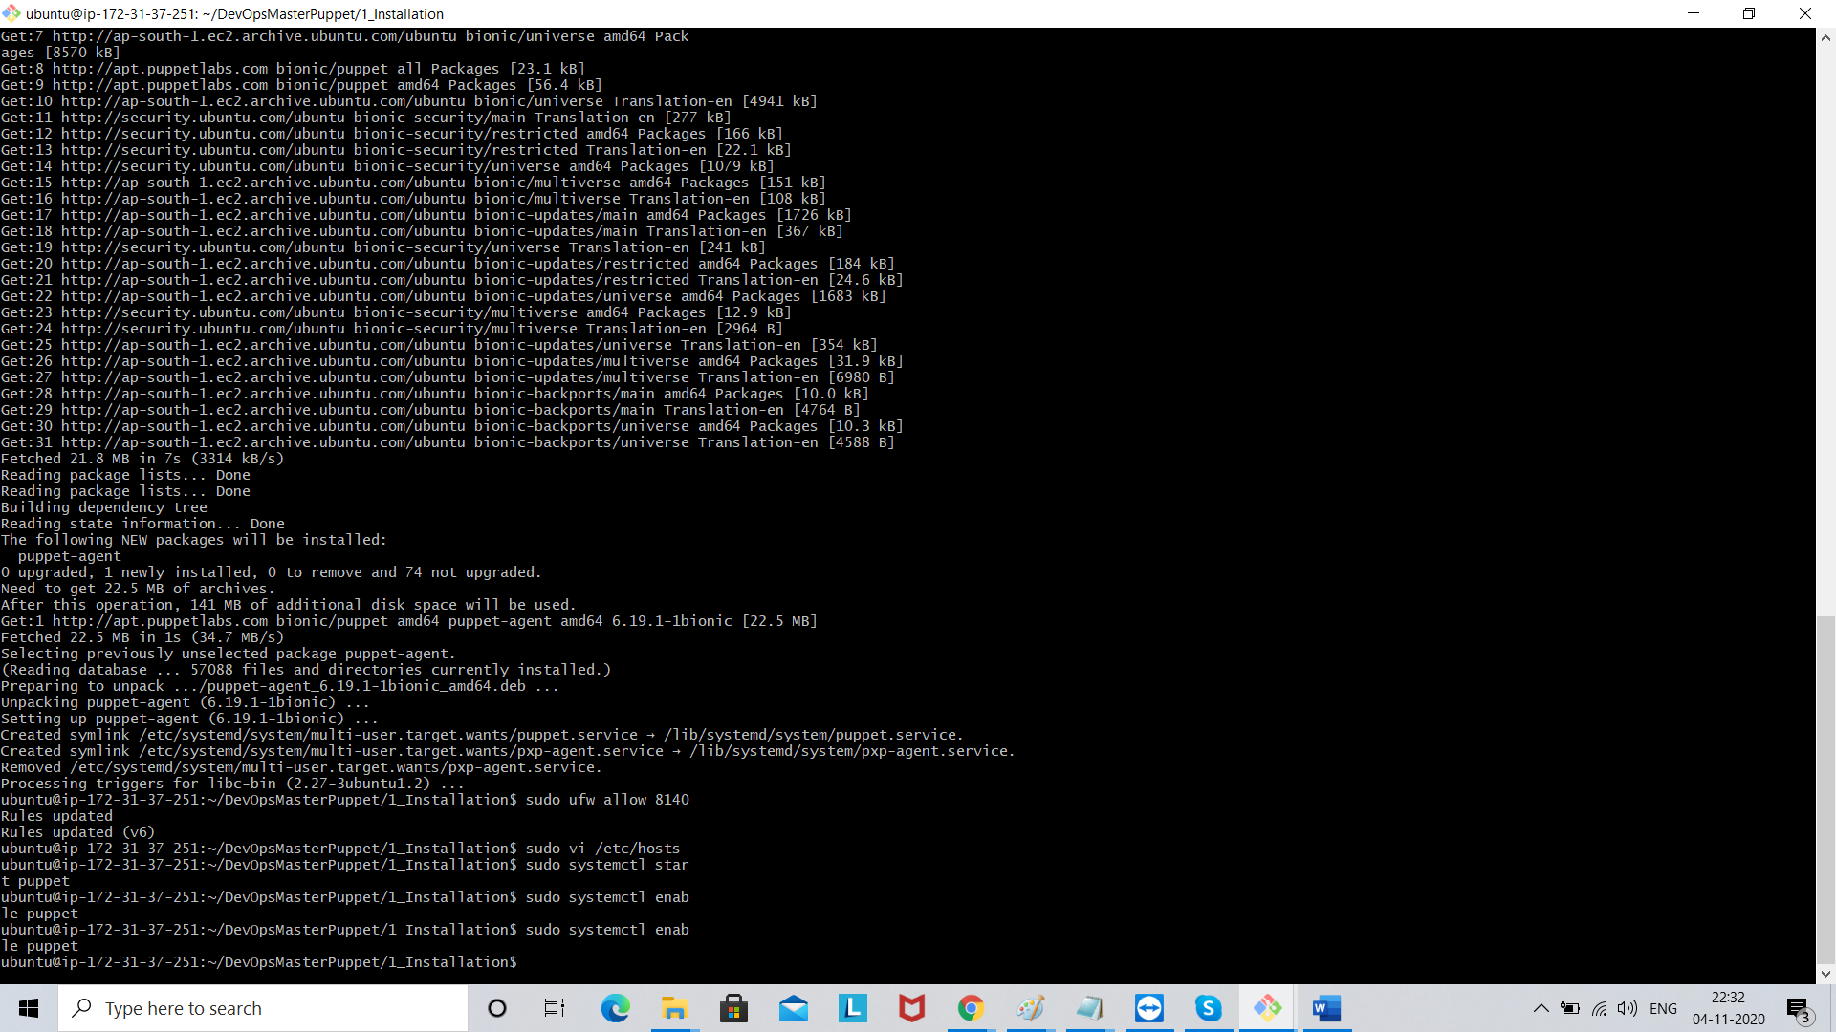

Wq!